201.1 Purpose

This section describes the treatment of vehicles.

201.2 General Information

All vehicles are excluded resources when determining Supplemental Nutrition Assistance Program (SNAP) eligibility. The type of vehicle does not matter (automobile, boat, recreational vehicle, or airplane, etc.).

Case managers are not required to complete motor vehicle screens to verify ownership of any vehicle.




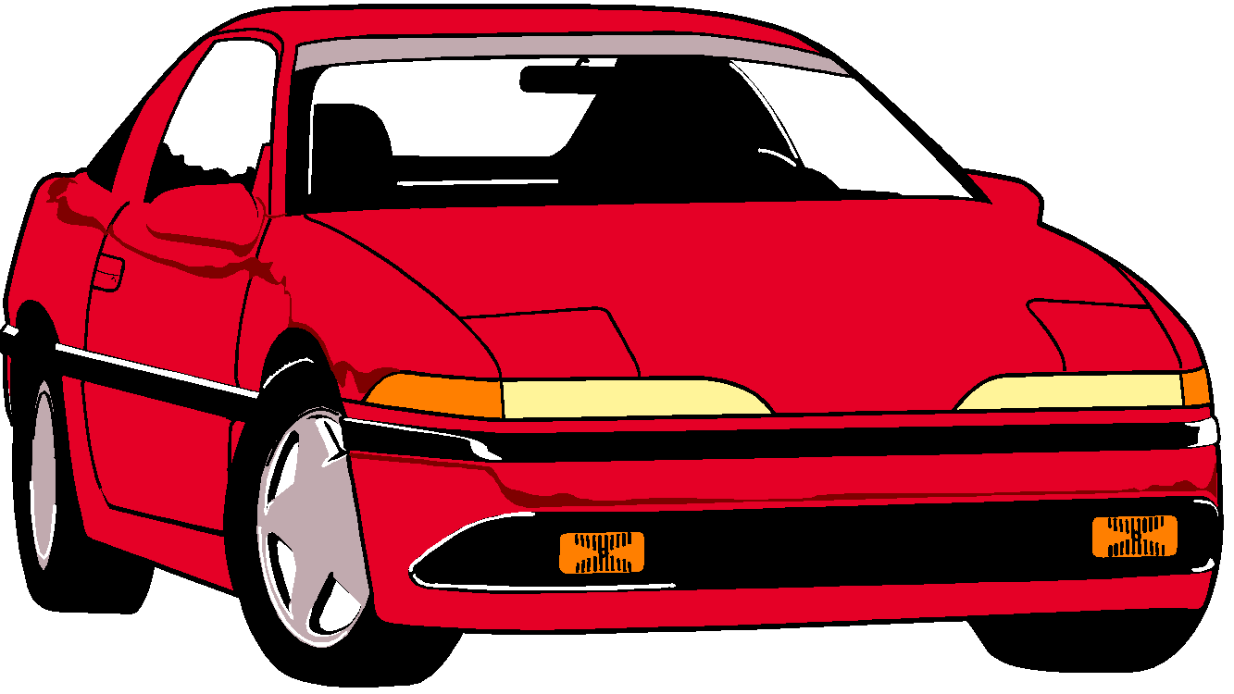
Vehicle and insurance payments are still considered when exploring the possibility of a deficit budget.
Do Not
Count!
These are excluded resources

