STATE OF MARYLAND

DEPARTMENT OF HUMAN SERVICES

FAMILY INVESTMENT ADMINISTRATION

PUBLIC ASSISTANCE TO ADULTS DISABILITY CERTIFICATION FORM
Public Assistance to Adults is a monthly payment of State funds to an individual who has been certified for a licensed assisted living program, a CARE home, or a Maryland Department of Health (MDH) rehabilitative residence.

SECTION I REPRESENTATIVE PAYEE’S AGREEMENT

In becoming a Representative Payee for __________________________ ___________________ ^{(Name of Customer)} ^{(Customer ID)}
I understand and agree to the following:

- To use the assistance payment to obtain shelter, food, clothing, etc. for the customer.

- To provide some accounting so that the local department can know how the money was used.

- To the best of my ability, assist the customer in meeting daily needs; help with ongoing problems, and to maintain a close contact with the customer.

- To report to the local department any change in the financial circumstances of the customer of which I am aware; or any change in my relationship to the customer.

_________________________ ______________________
Representative Payee Date

_________________________ ______________________
LDSS Case Manager’s Signature Date

SECTION II REHABILITATIVE RESIDENCE OR CARE HOME CERTIFICATION
See Section III for Assisted Living placements
The above-named client has been approved for service and will be placed in a CARE Home or Rehabilitative Residence facility.

Facility: _____________________________________________________________
Address: ____________________________________________________________
Telephone No: _______________________________________________________
Service Eligibility has been established for: _________________________________
Level of Care: ________________________________________________________
Planned Placement Date: _______________________________________________
Mail Check to: ________________________________________________________
Address: ____________________________________________________________
Placement approved by: ________________________________________________

SECTION III MEDICAL REPORT
(Section III must be completed for PAA-Assisted Living applicants/recipients. This section also may be used for CARE Homes and Rehabilitative Residence applicants when an agency determination of need is not available.)

The information provided on this form may be used to determine eligibility for federal and state programs using Social Security disability criteria.

Please Print or Type

PATIENT INFORMATION:
Is a protective living arrangement necessary? Yes No
If yes, Justification for Protected Living Arrangement on page 3 must be completed

Name of Patient: _________________________________ Date of Birth: ___________________
Name of Licensed Professional or Physician: ____________________________________________
Address: _________________________________________________________________________
Specialty: ________________________________________________________________________
Phone: ___________________________
Dates of Examination: First Visit: ____________ Last Visit: __________________
Presenting Symptoms: __________________________________________________________________________________
__________________________________________________________________________________
__________________________________________________________________________________

Diagnosis: ______________________________________ Onset Date: ______________________

Diagnosis: _______________________________________ Onset Date: ______________________

Hearing Limitations Yes No Minimal Moderate Extreme Severe

Speaking Limitations Yes No Minimal Moderate Extreme Severe

MENTAL HEALTH

Does the patient suffer from mental illness? Yes No
_______________________________________________________________________________________________________________________________________________________________________________________________________________________________________________________________

To the best of your knowledge does the patient exhibit any violent behaviors? Yes No
If yes, list below __________________________________________________________________________________________________________________________________________________________________________

SECTION IV VISUAL LIMITATIONS

Visual Field: OD ______________ OS ____________ VA _______________
(After corrections): OD___________ OS ____________ VA _______________

PROGNOSIS AND RECOMMENDATIONS

Patient’s vision impairment LEVEL (PLEASE INDICATE BELOW)

Stable ______ Deteriorating _____ Capable of Improvement______ Uncertain_______

Other recommendations (e.g., special eye consultation, special medical examination, low-vision aide, mobility training, prostheses, etc.; explain):

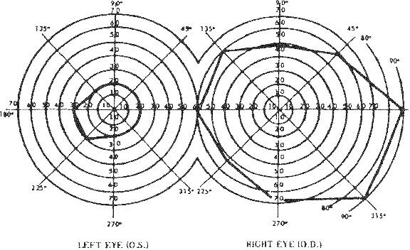

Justification for Protected Living Arrangement:
____________________________________________________________________________________________________________________________________________________________________________________________________________________________________________________________________________________________________________________________________________________

Additional Comments:
____________________________________________________________________________________________________________________________________________________________________________________________________________________________________________________________________________________________________________________________________________________
Signature: ____________________________________ Print Name: ____________________________
Title: ________________________________________ Telephone: ____________________________
License or Federal ID#: _________________________
MA Provider#: ________________________________ Date: _________________________________

