Department of Human Resources
Request for Proposals for
State Disbursement Unit Services
CSEA/SDU/14-001-S

QUESTIONS AND RESPONSES SERIES #3

- Question: For reconciliation purposes, please provide the number and type of bank accounts the SDU will manage. For example is there a separate account for paper, electronic, credit card payments, etc. Does the state have separate disbursement accounts?

Response: There is one depository account which rolls into a disbursement account overnight. The Contractor only works with the disbursement account when depositing state recoupment payments.
- Question: Please provide a screen shot of the LTR. How many LTRs were received by the
SDU per month for the last 24 months? Of this amount how many LTRs required a receipt adjustment?

Response: Based on the best information that is available to the State, the SDU received 66,412 LTRs from June 2011 to July 26, 2013. The State does not track the number of LTRs that require receipt adjustments. LTR screenshots are shown below.
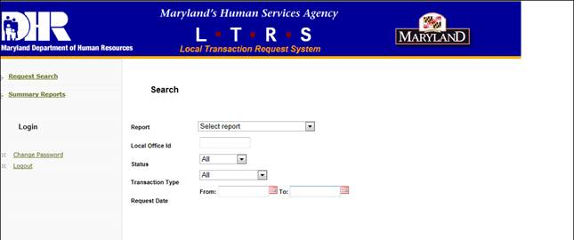

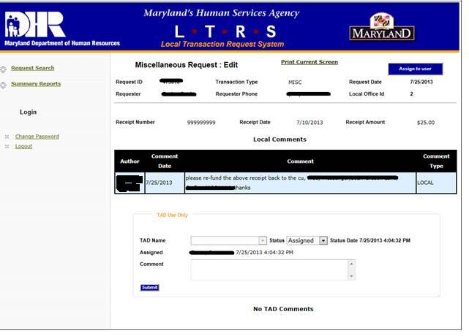
- Question: Which bank account is a state recoupment deposited? Are state recoupments
submitted on the Receipt File or manually posted to CSES by the SDU?

Response: The state recoupment payments are deposited into the disbursement account. State recoupments are posted to CSES by the SDU.
- Question: If the current SDU Contractor is required to provide a monthly credit card
payment report, please provide a copy of each of the last 12 reports.

Response: The current SDU Contractor is not required to provide a monthly credit card payment report.
- Question: The RFP’s scope of work requires the contractor to conduct outreach and
marketing for electronic payments but does not provide requirements specific to printing marketing and outreach materials; however, Attachment A includes printing of marketing materials. Is the contractor only required to print the marketing materials listed in Attachment A? To assist in determining the price, please provide a sample of each of the Marketing Materials listed in Attachment A: Direct Deposit Brochures/Enrollment Kits/Notices, the Employer Electronic Payment Enrollment, and the NCP Electronic Payment Enrollment Kits/Notices.

Response: The Contractor is required to create and print the marketing and outreach materials listed in Attachment A. Therefore Offerors should state in their proposals how they will adhere to these requirements. Please note that enrollment applications are usually only one page.
- Question: Please provide the incumbent’s monthly invoice in order to
know the volume being processed each month per item in order to propose the correct number of staff. We appreciate receiving the overall invoice amount and we understand that the transaction price is considered confidential. If invoices with redacted prices will not be provided, please provide the monthly volume for the last 12 months for each of the following items: Paper Payment Transaction, Electronic Payment Transaction, Electronic Payment Enrollment, Direct Deposit Enrollment, NSF Funds Payments, Recoupment/Receipt Adjustments, Stop Payment Requests, Void Requests, Payee Disbursement Hold, Releasing Funds in Escrow, Direct Deposit Brochures Printed, Direct Deposit Enrollment Printed, Employer Electronic Payment Enrollment Printed, NCP Electronic Payment Enrollment Printed.

Response: The State will not provide the current contractor’s invoices. However, a chart is attached that lists the number of transactions, by type, over the last 12 months. The information contained in the chart is based upon the best information available to the State.

